**Ideation Phase**

**Define the Problem Statements**

|  |  |
| --- | --- |
| Date | 31 January 2025 |
| Team ID | LTVIP2025TMID43995 |
| Project Name | Transfer Learning-based Classification of Poultry Diseases for Enhanced Health Management |
| Maximum Marks | 2 Marks |

**Customer Problem Statement Template:**

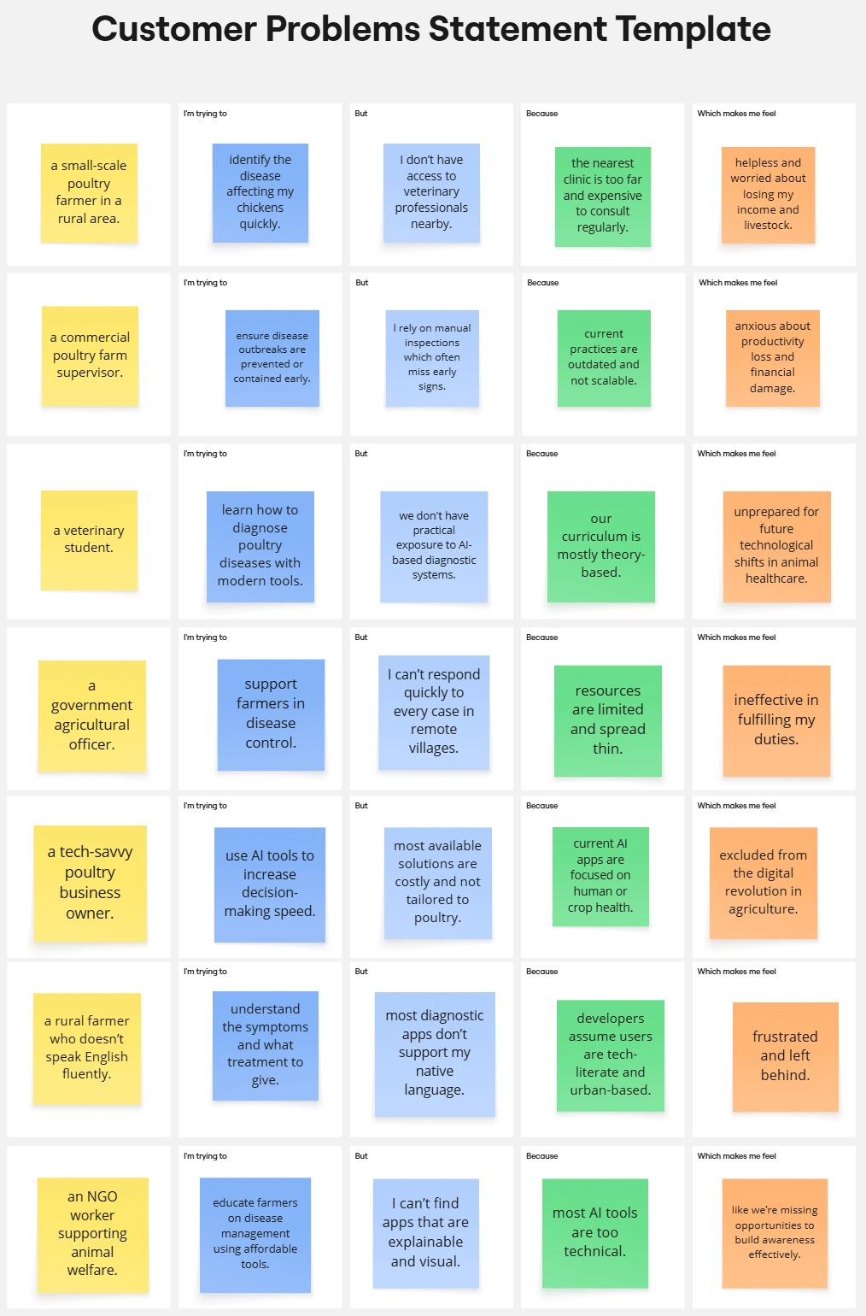

Reference: [Customer Problem Statement - Miro](https://miro.com/app/board/uXjVIjvNZ28=/)

|  |  |  |  |  |  |
| --- | --- | --- | --- | --- | --- |
| **Problem Statement (PS)** | **I am (Customer)** | **I’m trying to** | **But** | **Because** | **Which makes me feel** |
| PS-1 | a small-scale poultry farmer in a rural area. | identify the disease affecting my chickens quickly. | I don’t have access to veterinary professionals nearby. | the nearest clinic is too far and expensive to consult regularly. | helpless and worried about losing my income and livestock. |
| PS-2 | a commercial poultry farm supervisor. | ensure disease outbreaks are prevented or contained early. | I rely on manual inspections which often miss early signs. | current practices are outdated and not scalable. | anxious about productivity loss and financial damage. |
| PS-3 | a veterinary student. | learn how to diagnose poultry diseases with modern tools. | we don't have practical exposure to AI-based diagnostic systems. | our curriculum is mostly theory-based. | unprepared for future technological shifts in animal healthcare. |
| PS-4 | a government agricultural officer. | support farmers in disease control. | I can’t respond quickly to every case in remote villages. | resources are limited and spread thin. | ineffective in fulfilling my duties. |
| PS-5 | a tech-savvy poultry business owner. | use AI tools to increase decision-making speed. | most available solutions are costly and not tailored to poultry. | current AI apps are focused on human or crop health. | excluded from the digital revolution in agriculture. |
| PS-6 | a rural farmer who doesn’t speak English fluently. | understand the symptoms and what treatment to give. | most diagnostic apps don’t support my native language. | developers assume users are tech-literate and urban-based. | frustrated and left behind. |
| PS-7 | an NGO worker supporting animal welfare. | educate farmers on disease management using affordable tools. | I can’t find apps that are explainable and visual. | most AI tools are too technical. | like we’re missing opportunities to build awareness effectively. |